Title:

Are seed-dispersing ants elaiosome-limited? An experimental test in a Connecticut forest dominated by myrmecochorous plants

Author(s): Robert Emerson Clark1,2

1Great Hollow Nature Preserve and Ecological Research Center

2EcoData Technology LLC

Corresponding email:

rclark@greathollow.org

Abstract:

Food-for-dispersal mutualisms are critical sources of energy flow in ecological networks. By providing a nutrient-rich reward in the form of a fruit or seed to an animal mutualist, plants gain directed dispersal. Myrmecochory is one form of animal-mediated seed dispersal in which ants are recruited to plant seeds by providing a nutrient rich appendage called an elaiosome. It is unclear to what impact nutrients provided by elaiosomes have on ants, and whether the mutualism can tolerate disruptions to this food source. In the Northeastern U.S. mixed deciduous forest ecoregion, a diverse assemblage of herbaceous plants are dispersed by *Aphaenogaster* ants*.* Since *Aphaenogaster* ants gain a significant nutrient subsidy from this mutualism, it is predicted that loss of these seeds could cause reductions in their population size. To test this hypothesis, I performed a long-term removal of elaiosome food sources for ants. All seeds were removed by hand from three 50m2 plots, each paired with control plots with no removal, and a supplementation plot from April to May, from 2010 to 2012. Five years following removal treatments, I collected data on coverage of ant-dispersed plants and the abundance of seed-dispersing *Aphaenogaster* ants. Removal of all sources of elaiosomes resulted in modest reductions in the proportional coverage of ant-dispersed plants relative to control plots. Ant forager abundance was not impacted by the treatments five years after the removal of elaiosomes. In sum, *Aphaenogaster* populations may not always be limited by the availability of elaiosomes or myrmecochorous plants produce can recover quickly (<5 years) to provide enough food for these ants. As long as surrounding populations of understory forest plants are maintained, it appears that both mutualistic ants may rebound from a short-term reduction in the production of elaiosomes.

Key words: Mutualism, Dispersal ecology, Ants, Ant-dispersed plants, Forest food webs

1. Introduction:

Seed dispersal mutualisms are important components of terrestrial food webs since they represent a source of energy flow from plants to animals (Bascompte and Jordano 2007, Schleuning et al. 2015, Vader Wall et al. 2017). By providing a food source to animals in the form of fruit or seed tissue, plants can achieve directed dispersal to high-quality sites, while animal seed dispersers gain an important, target food source (Silva et al. 1997, Farwig and Berens 2012). Ant-dispersed plants (i.e. myrmecochores) present a syndrome of traits to recruit ant workers to seeds (Giladi 2006, Dunn et al. 2007). This plant guild includes a diverse assortment of over 11,000 species that employ this dispersal strategy, and produce diaspores with soft, lipid-rich appendages called elaiosomes (Warren and Giladi 2014). Elaiosomes are attractive to ants—foraging workers return the seeds to the parent colony, remove the elaiosomes to feed to brood, and then discard the remaining seed to ant colony middens (Morales and Heithaus 1998). Elaiosomes contain multiple nutrients that can be limiting for ant colony development, including fats and amino acids (Fischer et al. 2005). High abundance of both ant-dispersed plants and ants in some habitats suggest this is an important limiting food source for ant populations (Ness et al. 2009). Evidence for elaiosomes as a source of limiting nutrients originates from studies demonstrating that the nutritional needs of developing ant larvae are supplemented by the lipids in elaiosomes (Fischer et al. 2008). Consequently, elaiosome-bearing plants could have trophic impacts on ants by increasing number of workers or new colonies when ant populations are food-limited. However, tests of this “elaiosome-limitation hypothesis” are rare (but see Warren et al. 2019). Mechanistic work on the nutritional benefits of elaiosomes have focused on ant colony traits or fitness (e.g. Bono and Heithaus 2002, Gammans et al. 2005), rather than ant population-level abundance in field conditions.

Myrmecochory is common in temperate forest understory plants for spring-ephemeral and summer-ephemeral life history strategies (Beattie and Culver 1981, Boulay et al. 2007). Spring ephemerals have short leafing and flowering times, often senescing before the forest canopy closes. In eastern North American forest habitats, *Aphaenogaster* ants are often numerically dominant, and evidence suggests these ants are the most effective dispersal mutualist for myrmecochores. *Aphaenogaster* ants rapidly discover and move diaspores (Smith et al. 1989), which prevents seed predation (Heithaus 1981, Ruhren and Dudash 1996). Given the ubiquity of *Apheanogaster* in deciduous forests of in eastern North America, the “elaiosome-limitation hypothesis” has been primarily tested in this system (e.g., Warren et al. 2019). In particular, elaiosomes as a supplemental food source for *Aphaenogaster* colonies and can be important when insect prey is less available (Clark and King 2012). While *Aphaenogaster* are specialized as seed dispersing ants, it is less clear to what degree this is an obligate mutualism limiting their populations.

Demonstrating whether or not seed dispersing ants are limited by the availability of elaiosomes is an important objective for the protection of ant-dispersed plant communities. Given the specificity of this mutualism, there is concern that habitat disturbance and fragmentation could negatively impact myrmecochorous communities or their seed-dispersing ants like *Aphaenogaster* (Ness and Morin 2008, Parker et al. 2021). Myrmecochores in these systems are predominantly spring ephemerals and seasonal greens that can dominate the herbaceous plant layer in intact closed-canopy mixed-deciduous forests (Handel et al. 1981). However, in smaller forest fragments, edge effects might drive reduced abundance of myrmecochores and seed-dispersing ants (Ness and Morin 2008). With the loss of these food sources due to habitat fragmentation, there could be cascading effects driving decline of this putative mutualist ant *Aphaenogaster*.

The goal of this study was two-fold: First, to describe the diversity of ant-dispersed plants in the understory of Connecticut forests. In the study area of this experiment (New Haven, Hartford, and Litchfield Co., Connecticut, USA), there is not a comprehensive list of ant-dispersed plants nor data on the relative abundance of these plants in forest understories. Second, since long-term data on ant-myrmecochore interactions are limited (Heinken and Winkler 2009), I tested the “elaiosome-limitation hypothesis” in an environment in which myrmecochores dominate. Food limitation for populations is often context dependent, so this study addresses loss of elaiosomes for a short-time period in one single habitat type. In this specific location, I predicted that locations in which myrmecochores were exceptionally abundant would represent areas where the carrying capacity of *Aphaenogaster* could be manipulated if this pulse of nutrients was consistently found at high frequency. In all, there are relatively few studies indicating the importance of elaiosomes for populations of Aphaenogaster, particularly in situations where this food source is not available for more than one growing season.

2. Material and Methods:

2.1. *Surveys and description of Connecticut ant-dispersed plants*

I reviewed the literature on herbaceous myrmecochorous plants, searching for species with known records in Connecticut forests that are native, non-woody, non-graminoid plants. I queried Web of Science with the search terms “myrmecochor*”, “elaiosome*”, and “ant” + “dispersed” + “plant”. Reviewing the abstract, I verified if the study was about ant-dispersed plants and created a list of species found in studies conducted in eastern North America. With this species list, I used online references, including the New England region maps on GoBotany.com (Native Plant Trust 2021), to see which plant species had distributions including any Connecticut counties. Connecticut myrmecochores were included in Table 1 if they met one of two criteria: ant dispersal was previously validated through behavioral observation of seed removal (e.g. Gaddy 1986) or nutritional assays in which ants consumed elaiosomes (e.g. Bono and Heithaus 2002). In two cases plant species in a shared species complex were included as all other members of that genus or species complex were also ant-dispersed, but this stipulation is denoted in Table 1. All herbaceous plants I observed in Connecticut during transect surveys were also checked for evidence of ant-mediated seed dispersal following the same literature review criteria. Current scientific names and life history (annual or perennial) of all plant species verified using USDA PLANTS database (NCRS 2022). Additionally, plants seen during surveys or while collecting seeds for Clark and King (2012) were checked within the literature. These species lists were also checked following the same approach as the literature review. To be added to Table 1, evidence of behavioral observation or feeding were necessary (ranging from Robertson 1897 to Warren and Bradford 2014). The genus *Viola* has been systematically revised since most reports of ant dispersal were published (e.g., Culver and Beattie 1978). Thus, *Viola* reported in Table 1 were updated to reflect the most current names in the New England region reported through GoBotany.com (Native Plant Trust 2021).

In 2009-2010, I completed four surveys on ant-dispersed plant abundance in secondary forests. The goal of these surveys was to provide preliminary data on the most common species found across three different classes of secondary forests typical to the state of Connecticut (each >20km from each other). To test the elaiosome-limitation hypothesis, I sought to find a location in which ant-dispersed plants numerically dominate the understory plant community. At each site, I designated transects starting at the habitat edge and continued inward to the center of the forest fragment. A meter tape was laid down across the forest floor and pinned with a tent stake at both ends. Plants overhanging this line were quantified by measuring the total coverage over our transect lines in cm. Sampling effort varied among sites, for more details on the size of transects, see Figs. S1-S5. All non-graminoid, herbaceous, vascular plants were identified species, including both ant-dispersed and non-ant dispersed plants.

2.2. *Simulating loss of elaiosomes at Henry Buck Trail*

I employed a manipulative experiment to remove all sources of elaiosomes in plots arranged in a 3x3 factorial design. There were three replicates for each treatment making up nine plots at 50m2 each (Fig S1). I chose to conduct the habitat manipulation at the site where the highest species richness of myrmecochores were present (Henry Buck Trail, Fig. S2). In 2010, 2011, and 2012, I removed all potential sources of elaiosomes that could be provided to the ant community. I removed the following by hand: developing flower heads of all apparent myrmecochores, visible flowers, developing seed pods, and entire diaspores. Removal took place in April-May each year (one visit each month) to ensure all members of this plant guild could be manipulated. Given density estimates of April 2010 preliminary transects, for removal treatment, I removed >155,000 flowers or seed pods over the three-year manipulation. In a third positive treatment, I supplemented plots with all *Trillium* seed pods that were extracted from removal treatments immediately following completion of each block on the same day. *Trillium* has large, apparent seeds in which ants remove elaiosomes (personal observations, Gunther and Lanza 1989). *Trillium* supplementation was used as a complimentary test of the elaiosome limitation hypothesis. I predicted that a supplementation of a single myrmecochore species can impact *Aphaenogaster* populations or foraging activity.

Three years of elaiosomes removal deprived colonies located within these transects for a long-term period. The time period represents a long-term exclusion of this nutritional resource, and it would be difficult for *Aphaenogaster* in these plots to collect many elaiosomes outside the manipulated area given that their 0.67 to 1.6 m2 foraging territory is smaller than the plots (Weseloh 1994, Lubertazzi 2012). Furthermore, many ant-dispersed plants have restricted dispersal distance, and while recolonization can occur, it is typically at a slow rate (Anderson 1988, Sasidharan and Venkatesan 2019). The eight-year period (three-year removal, five-year sampling delay) represents the time in which new colonies could be produced and develop given that *Aphaenogaster* colonies have a median lifespan of eight years, and new colony development could take up to two years (Lubertazzi 2012).

To assess ant population response to changes in elaiosome availability, I measured the colony-level foraging activity of *Aphaenogaster* and other ground-foraging antson May 15 2017 (*Apheanogaster* colony sampling method modified from Lubertazzi 2012, Mitchell et al. 2002). In this assay, five cookie baits (pecan sandies) were placed within each of the larger sub-plots and left for two hours in mid-day (Fig. S6). One bait was placed in the center of each plot, while the other four baits were placed in the corner 2 meters from the plot border. After the 2-hour waiting period, I returned to count and identify ant species with workers actively taking pieces of bait. If multiple ants were collecting baits and moving in a single column, I followed workers to a nest entrance to verify them as representatives of a single, shared colony. A single worker of a one species was also counted as representing a single unique colony.

To evaluate the reduction in elaiosome availability in response to my removal and addition manipulations, I completed a complete plant-community survey in May 2017, using line transect sampling at each sub-plot (Fig S6). Two line transects were laid diagonally in each plot, making a total transect length of 140m. This method gave detailed total coverage of every ant-dispersed plant species and all other plant species (pooled together as “non-ant-dispersed plants”).

2.3. *Statistical methods:*

Three approaches were used for statistical analysis in R version 4.0.5 (R working group, 2021). To quantify the impact of treatments (i.e., experimental removal or addition of sources of elaiosomes), I employed an analysis of proportional plant coverage at Henry Buck. This was fitted as a binomial Generalized Linear Mixed Model (GLMM) using the lme4 package (Bates et al. 2015). Model estimates, such as predicted mean, standard error, and post-hoc tests, were extracted using the emmeans package (Lenth 2016). P-values for fixed effects were calculated using the car package (Fox and Weisberg 2011). To evaluate the impact of treatments on *Trillium* coverage, I ran one follow up GLMM using the same model specifications, but with total coverage of *Trillium* fitted to a negative binomial distribution. All GLMMs used block as a random effect and elaiosome manipulation treatment as a fixed effect. To evaluate treatment effects on ant colony abundance and *Trillium* abundance, a Kruskal-Wallis rank test was employed due to the highly non-normal structure of these data (Ruxton and Beauchamp 2008). For analysis of species richness (estimated site-specific rarefaction), I used the vegan package (Osksanen et. al. 2019). Estimates of diversity in the plant species pool used *Chao1* index to make comparisons across sites with varying sampling effort (e.g. Dilworth et al. 2021).

3. Results:

My literature and field surveys revealed there are 25 records of native, herbaceous, ant-dispersed plants following our search criteria. These are predominantly native spring ephemerals found in the region’s mixed-deciduous forests, and with the exception of *Corydalis flavula* and *Melampyrum lineare*, all are perennial wildflowers. The species richness and composition of the plant communities surveyed is reported in supplemental tables and figures S2-S5, with Trout lily *(Erythronium americanum*) being the only myrmecochore species found at all sites. Notably, line transects revealed that the highest species richness of ant-dispersed plants was observed at the Henry Buck Trail at American Legion State Forest in Barkhamsted, CT (Fig S2). Myrmecochore species richness and coverage was noticeably higher than estimates from larger region-wide surveys (Warren et al. 2021). Thirteen myrmecochore species occurred in this site’s transect and the site had a percent coverage for myrmecochores of 87.2% within the herbaceous layer.

My post-manipulation plant community surveys at Henry Buck trail demonstrate ant-dispersed plants still dominated the proportional cover of the understory, herbaceous layer. Dutchman’s breeches (*Dicentra cucullaria*), Red trillium (*Trillium erectum*), Spring beauty (*Claytonia virginica*), and Trout Lily (*Erythronium americanum*) were the four most abundant ant-dispersed plants at the end of this survey (Fig. 1). Hand-removal treatments had a modest reduction in the proportional coverage of ant dispersed plants, but this difference was indeed significantly different (Fig 2, Binomial GLMM, χ2 = 16.85, df = 2, *P* < 0.001). Control plots with no manipulation had the highest proportional coverage of ant-dispersed plants (Fig. 2, Tukey HSD). In terms of magnitude of this effect, 73.8% of the transects in control plots were covered by ant-dispersed plants, compared to 67.3% in removal plots, indicating they were still dominant in terms of leaf area. *Trillium* supplementation plots did not result in increased numbers of *Trillium* plantscompared to controls (Negative binomial GLMM, posthoc test, *Z* ratio = -2.00, *P* = 0.112). Similarly, *Trillium* supplementations plots did not have significant more *Trillium* plants compared to removal plots either (Negative binomial GLMM, posthoc test, Z ratio = -1.46, *P* = 0.309). Plots with addition of *Trillium* seeds to plots had intermediate proportional covered by ant-dispersed plants overall (Fig. 2, Tukey HSD). In all, these results suggest that the manipulation only moderately reduced the proportional abundance of myrmecochores and they remained dominant over non-myrmecochores with respect to herbaceous plant cover (Fig. 2).

Surveys of the ground-foraging ant community and *Aphaenogaster* colony abundance yielded five species of ants, including *Aphaenogaster rudis* group, *Camponotus pennsylvanicus*, *Lasius neoniger*, *Myrmica punctiventris,* and *Tapinoma sessile*. With respect to timing, this baiting assay took place six years after the last manipulation of all sources of elaiosomes in removal treatments. I observed no difference in the abundance of seed-dispersing *Aphaenogaster* colony abundance among removal, control, or supplementation treatments (Fig. 3, Kruskal-Wallis, χ2 = 1.15, df = 2, *P* = 0.56). In the control treatments 1.33 (SE 0.25) *Aphaenogaster* colonies were observed, compared to 1.53 (SE 0.16) in the removal, and 1.26 (SE 0.26) in the supplementation. Additionally, there was no difference among treatments in the recruitment of non-*Aphaenogaster* ant colonies to these baits (Kruskal-Wallis, χ2 = 0.78, df = 2, *P* = 0.67). For non-*Apheanogaster* ants, 2 (SE 0.74) colonies were observed in the control treatments, 2.53 (SE 0.85) in the removal, and 2.2 (SE 0.67) in the supplementation.

4. Discussion:

The impact of anthropogenic disturbance disrupts dispersal mutualisms (Markl et al. 2012). Specialized mutualisms are particularly susceptible to extinctions because if one partner is extirpated from an environment, the mutualistic partner risks demographic failure (Farwig and Berens 2012). My results indicate that in intact forests ant-myrmecochore mutualisms might be able to tolerate loss of elaiosome-bearing seeds for a short period of time. If elaiosomes are not produced for three years, myrmecochores were still able to persist as dominant members of the understory herbaceous plant community and *Aphaenogaster* were still active in both removal and control plots. This ability of myrmecochores to persist following this disturbance may be explained by the dominance of perennial myrmecochores in this community since only two species were found to be annuals. Conversely, large-scale habitat changes may require longer time scales for recovery of ant-dispersed plants (Sorrells and Warren 2001). Climate may also impact mutualistic interactions, as different ant-dispersed plants can stagger seed release throughout the season to avoid competition (Warren et al. 2014). The phenological pattern of myrmecochores could be disrupted by climate change if seed release and ant activity become asynchronous (Warren et al. 2010). Our experiment did not entirely remove all seeds from the habitat, only small plots. At a larger scale, depleted seed banks can severely limit recovery for herbaceous plants (Lang and Halpern 2007). Seed depletion may be slower to recover from given some reports of high seed-predation rates for myrmecochores in the U.S.’s eastern deciduous forests (Heithaus 1981).

Contrary to the predictions of the elaiosome-limitation hypothesis, I did not observe evidence of a population-level impact of elaiosome removal on *Aphaenogaster* foraging activity. I observed no change in the recruitment of *Aphaenogaster* workers to baits during our sampling process, matching findings from in which removal of elaiosome-bearing plants did not reduce *Aphaenogaster* worker abundance or nest occupancy (Warren et al. 2019). In other systems, seed-dispersing ants can be limited by other resources other than elaiosomes. For example, surveys show that *Aphaenogaster* are probably not elaiosome-limited in small forest fragments (Mitchell et al. 2002). However, my results should be interpreted carefully as the study area only encompasses a single population of *Aphaenogaster* colonies and the study lacks data on *Aphaenogaster* abundance prior to elaiosome removal. *Aphaenogaster rudis* group ants form ephemeral nests in spring and summer, moving to more permanent locations to overwinter (Lubbertazzi 2012), thus it is possible that over long time periods colonies located near the border of experimental plots could move out of the removal area. Additionally, elaiosomes’ nutrients may provide other resources to ants that are important for performance outside colony size or density, such as the production of winged alates (i.e., reproductive castes). While closer analysis of nutrition acquisition from elaiosomes show weak impacts on reproduction or sex allocation in colonies of seed-dispersing ants (Caut et al. 2013), other work on *Apheanogaster* collected from Connecticut forests show elaiosomes could be an important source of nutrients for brood production by queens (Clark and King, 2012).

My experiment is limited due to the geographic focus on a single forest system, and the patterns observed may be different in other forest fragments. I intentionally chose a site where myrmecochores were abundant to test this hypothesis, but the impacts on *Aphaenogaster* for myrmecochore removal might be more severe in marginal habitats where myrmecochores are comparatively rare members of the understory plant community. For example, *Aphaenogaster* are less common on the edge of forest fragments as well as some of their plant mutualists (Ness and Morin 2008). Like in other seed-dispersal mutualisms, reduced abundance of *Aphaenogaster* may be the result of habitat fragmentation and competition from invasive species (Rodriguez-Cabal et al. 2012, Meadley Dunphy et al. 2016). Finally, the experiment performed here could be improved with a longer-term removal and sampling regime in which the response to elaiosome loss is measured with starting conditions of myrmecochore and *Aphaenogaster* populations. For our myrmecochore species found in surveys, twenty-three out of twenty-five were perennial plants, including all species of *Trillium*, meaning a longer removal period of seeds may be required to significantly reduce the populations of mature plants.

Finally, several factors may explain why we saw no effects of manual elaiosome removal on *Aphaenogaster* foraging activity. *Aphaenogaster* may have recovered quickly following the three-year removal, returning to prior numbers for the multiple growing seasons occurring between removal and the bait assay. Other conditions may be site-specific. For example, *Aphaenogaster* potentially benefit most from elaiosomes when insect prey can be scarce (Clark and King 2012). However, at this site insect prey may not be limiting at all. At other locations where insect prey is less available, there could be a significant population-level impact of elaiosomes. but this gap in food availability perhaps did not occur at the field site selected. Furthermore, the nutritional benefits of elaiosomes vary greatly among plant species (Pfeiffer et al. 2010) and our site may have included myrmecochores that provide a relatively low reward. Lower relatively nutritional quality of elaiosomes may explain why removal had a minimal impact on *Aphaenogaster*. It is possible that elaiosomes of higher quality may be provided by a different plant-community composition than the one observed at the site this experiment was conducted.

5. Conclusions:

In order to understand seed dispersal ecology, it is critical to establish the benefits both dispersers and plants receive from the interaction. In plants, ant-mediated seed-dispersal syndrome shows clear specialization for recruiting and attracting ants. Plants gain wide-ranging fitness benefits, including mechanisms like protection from natural enemies or movement to high-quality microsites. *Aphaenogaster rudis* are often the most effective ant species with regard to successful seed dispersal of many myrmecochore species (Ness et al. 2009). Conversely, there is less evidence that *Aphaenogaster* or other seed-dispersing ants are participating in a mutualism. For ants, myrmecochory may vary from mutualism, to commensalism, even to parasitism (Warren et al. 2019). It appears likely that *Aphaenogaster* are dependent on elaiosomes only under certain environmental contexts (Clark and King 2012).With regards to the conservation of forest understory plants and spring ephemerals, it is encouraging to know that gaps in the availability of elaiosomes are unlikely to negatively impact *Aphaenogaster* populations alone. Recent large-scale surveys in eastern US forests showed ant-dispersed understory plants are not necessarily more dispersal limited than other dispersal modes (Warren et al. 2021). While elaiosomes represent a large pulse of nutrients for ants represented by a diversity of species found in the understory of Connecticut forests, this seed dispersal service provided by ants is resilient to short-term reductions in elaiosome production. Further work should investigate how changes to climate or large-scale disturbances might negatively impact these seed-dispersal mutualisms in forest fragments.

Competing interests statement: The author has no competing interests to declare.

Acknowledgements: I thank the staff at American Legion State Forest (Connecticut Department of Energy and Environmental Protection, Parks Division) for allowing me to tag and manipulate plants in Barkhampsted, CT. Josh King (University of Central Florida) provided guidance on the experimental plot layout. Multiple volunteers contributed to the laborious removal experiments, including Melissa Bernardo, Chris Berthiaume, Megan Clark, Joe McLaughlin, and Lauren Verner. Taiga Araki assisted with ant baits and ant-dispersed plant coverage surveys. I also thank Jack Tessier (State University of New York at Delhi) for reviewing the myrmecochores of Connecticut species list. Chad Seewagen (Great Hollow Nature Preserve & Ecological Research Center) and Vera Pfeiffer (Washington State University) provided helpful feedback on drafts of this manuscript.

Appendix A. Supplementary figures and data for this article has been submitted with this manuscript.

References

Andersen, A.N., 1988. Dispersal distance as a benefit of myrmecochory. Oecologia 75, 507–511. <https://doi.org/10.1007/BF00776412>

Bascompte, J., Jordano, P., 2007. Plant-Animal Mutualistic Networks: The Architecture of Biodiversity. Annu. Rev. Ecol. Evol. Syst. 38, 567–593. <https://doi.org/10.1146/annurev.ecolsys.38.091206.095818>

Bates, D., Maechler, M., Bolker, B., Walker, S., (2015). Fitting linear mixed-effects models using lme4. J. Stat. Softw. 67, 1-48. <https://doi.org/10.18637/jss.v067.i01>

Beattie, A.J., Lyons, N., 1975. Seed dispersal in *Viola* (Violaceae): adaptations and strategies. Am. J. Bot. 62, 714–722. <https://doi.org/10.2307/2442060>

Beattie, A.J., Culver, D.C., 1981. The guild of myrmecochores in the herbaceous flora of West Virginia forests. Ecology 62, 107–115. <https://doi.org/10.2307/1936674>

Bellemare, J., Motzkin, G., Foster, D.R., 2002. Legacies of the agricultural past in the forested present: an assessment of historical land-use effects on rich mesic forests. J. Biogeogr. 29, 1401–1420.

Bono, J.M., Heithaus, E.R., 2002. Sex ratios and the distribution of elaiosomes in colonies of the ant, Aphaenogaster rudis. Insectes soc. 49, 320–325. <https://doi.org/10.1007/PL00012655>

Boulay, R., Coll-Toledano, J., Manzaneda, A., Cerdá, X., 2007. Geographic variations in seed dispersal by ants: Are plant and seed traits decisive? Sci. Nat. 94, 242–6. <https://doi.org/10.1007/s00114-006-0185-z>

Caut, S., Jowers, M.J., Cerda, X., Boulay, R.R., 2013. Questioning the mutual benefits of myrmecochory: a stable isotope-based experimental approach. Ecol. Entomol. 38, 390–399. <https://doi.org/10.1111/een.12028>

Clark, R.E., King, J.R., 2012. The ant, *Aphaenogaster picea*, benefits from plant elaiosomes when insect prey is scarce. Environ. Entomol. 41, 1405–1408. <https://doi.org/10.1603/en12131>

Culver, D.C., Beattie, A.J., 1978. Myrmecochory in *Viola*: Dynamics of seed-ant interactions in some West Virginia species. J. Ecol. 66, 53–72. <https://doi.org/10.2307/2259181>

Dilworth, K., Borowiec, M., Cohen, A., Mickelson, G., Oeller, E., Crowder, D., Clark, R., 2021. Ants of the Palouse Prairie: diversity and species composition in an endangered grassland. Biodivers. Data J. 9, e65768. <https://doi.org/10.3897/BDJ.9.e65768>

Dunn, R., Gove, A., Barraclough, T., Givnish, T., Majer, J., 2007. Convergent evolution of an ant-plant mutualism across plant families, continents, and time. Evol. Ecol. Res. 9, 1349-1362. <http://hdl.handle.net/20.500.11937/27347>

Farwig, N., Berens, D.G., 2012. Imagine a world without seed dispersers: a review of threats, consequences and future directions. Basic Appl. Ecol. 13, 109-115. <https://doi.org/10.1016/j.baae.2012.02.006>

Fischer, R.C., Richter, A., Hadacek, F., Mayer, V., 2008. Chemical differences between seeds and elaiosomes indicate an adaptation to nutritional needs of ants. Oecologia 155, 539–547. <https://doi.org/10.1007/s00442-007-0931-8>

Fischer, R.C., Ölzant S.M., Wanek W., Mayer V., 2005. The fate of *Corydalis cava* elaiosomes within an ant colony of *Myrmica rubra*: elaiosomes are preferentially fed to larvae. Insectes Soc. 52, 55-62.

Fox, J., Weisberg, S., 2011. An R Companion to Applied Regression. Sage Publications, Thousand Oaks, California.

Gammans, N., Bullock, J.M., Schönrogge, K., 2005. Ant benefits in a seed dispersal mutualism. Oecologia 146, 43–49. <https://doi.org/10.1007/s00442-005-0154-9>

Gaddy, L.L., 1986. Twelve new Ant-dispersed species from the Southern Appalachians. Bull. Torrey Bot. Club. 113, 247–251. <https://doi.org/10.2307/2996363>

Gibson, W., 1993. Selective advantages to hemi-parasitic annuals, genus *Melampyrum*, of a seed-dispersal mutualism involving ants: I. favorable nest sites. Oikos 67, 334–344. <https://doi.org/10.2307/3545480>

Giladi, I., 2006. Choosing benefits or partners: a review of the evidence for the evolution of myrmecochory. Oikos 67, 334-344. <https://doi.org/10.1111/j.0030-1299.2006.14258.x>

Gunther, R.W., Lanza, J., 1989. Variation in attractiveness of *Trillium* diaspores to a seed-dispersing ant. Am. Midl. Nat. 122, 321–328. <https://doi.org/10.2307/2425919>

Handel, S.N., Fisch, S.B., Schatz, G.E., 1981. Ants disperse a majority of herbs in a mesic forest community in New York state. Bull. Torrey Bot. Club. 108, 430–437. <https://doi.org/10.2307/2484443>

Heinken, T., Winkler, E., 2009. Non-random dispersal by ants: Long-term field data versus model predictions of population spread of a forest herb. Perspect. Plant Ecol. Evol. 11, 1–15. <https://doi.org/10.1016/j.ppees.2008.11.001>

Heithaus, E.R., 1981. Seed predation by rodents on three ant-dispersed plants. Ecology 62, 136–145. <https://doi.org/10.2307/1936677>

Lang, N., Halpern, C., 2007. The soil seed bank of a montane meadow: Consequences of conifer encroachment and implications for restoration. Can. J. Bot. 85, 557–569. <https://doi.org/10.1139/B07-051>

Lenth, R.V., 2016. Least-Squares Means: The R package lsmeans. J. Stat. Softw. 69:1-33.

Lubertazzi, D., 2012. The biology and natural history of *Aphaenogaster rudis*. Psyche 2012, e752815. <https://doi.org/10.1155/2012/752815>

Ness, J.H., Morin, D.F. Giladi, I., 2009. Uncommon specialization in a mutualism between a temperate herbaceous plant guild and an ant: Are *Aphaenogaster* ants keystone mutualists? Oikos 118, 1793-1804. <https://doi.org/10.1111/j.1600-0706.2009.17430.x>

Ness, J.H., Morin, D.F., 2008. Forest edges and landscape history shape interactions between plants, seed-dispersing ants and seed predators. Biol. Conserv. 141, 838–847. <https://doi.org/10.1016/j.biocon.2007.12.029>

Markl, J.S., Schleuning, M., Forget, P.M., Jordano, P., Lambert, J.E., Traveset, A., Wright, S.J., Böhning-Gaese, K., 2012. Meta-analysis of the effects of human disturbance on seed dispersal by animals. Conserv. Biol. 26, 1072–1081. <https://doi.org/10.1111/j.1523-1739.2012.01927.x>

Meadley Dunphy, S.A., Prior, K.M., Frederickson, M.E., 2016. An invasive slug exploits an ant-seed dispersal mutualism. Oecologia 181, 149–159. <https://doi.org/10.1007/s00442-015-3530-0>

Miller, J.M., Chambers, K.L., 2006. Systematics of *Claytonia* (Portulacaceae). Syst. Bot. Monogr. 78, 1–236. <http://dx.doi.org/10.2307/25027952>

Mitchell, C.E., Turner, M.G., Pearson, S.M., 2002. Effects of historical land use and forest patch size on myrmecochores and ant communities. Ecol. Appl. 12, 1364–1377. <https://doi.org/10.2307/3099977>

Morales, M.A., Heithaus E.R., 1998. Food from seed-dispersal mutualism shifts sex ratios in colonies of the ant *Aphaenogaster rudis*. Ecology 79, 734-739. [https://doi.org/10.1890/0012-9658(1998)079[0734:FFSDMS]2.0.CO;2](https://doi.org/10.1890/0012-9658(1998)079%5B0734:FFSDMS%5D2.0.CO;2)

Native Plant Trust. 2021. Go Botany [WWW Document]. URL [https://www.gobotany.nativeplanttrust.org](https://www.gobotany.nativeplanttrust.org/) (accessed 12.13.2021).

Oksanen, J., Blanchet, F.G., Friendly, M., Kindt, R., Legendre, P., McGlinn, D., Minchin, P.R., B, R., O’Hara, G., Simpson, L., Solymos, P., Henry, M., Stevens, H., Szoecs, E., Wagner, H., 2019. vegan: Community ecology package. R package version 2.5-5. <https://CRAN.R-project.org/package=vegan>

Parker, W.J., Buono, C.M., Prior, K.M., 2021. Antagonistic and mutualistic interactions alter seed dispersal of understory plants at forest edges. Ecosphere 12, e03397. <https://doi.org/10.1002/ecs2.3397>

Pfeiffer, M., Huttenlocher, H., Ayasse, M., 2010. Myrmecochorous plants use chemical mimicry to cheat seed-dispersing ants. Funct. Ecol. 24, 545–555. <https://doi.org/10.1111/j.1365-2435.2009.01661.x>

Ruhren, S., Dudash, M., 1996. Consequences of the timing of seed release of *Erythronium americanum* (Liliaceae), a deciduous forest myrmecochore. Amer. J. Bot. 83, 633-640. <https://doi.org/10.2307/2445923>

Ruxton, G.D., Beauchamp, G., 2008. Some suggestions about appropriate use of the Kruskal-Wallis test. Anim. Behav*.* 76, 1083-1087.

Robertson, C., 1897. Seed crests and myrmecophilous dissemination in certain plants. Bot. Gaz. 23, 288–289. <https://doi.org/10.1086/327511>

Rodriguez-Cabal, M.A., Stuble, K.L., Guénard, B., Dunn, R.R., Sanders, N.J., 2012. Disruption of ant-seed dispersal mutualisms by the invasive Asian needle ant (*Pachycondyla* *chinensis*). Biol. Invasions 14, 557–565. <https://doi.org/10.1007/s10530-011-0097-5>

Sasidharan, R., Venkatesan, R., 2019. Seed elaiosome mediates dispersal by ants and impacts germination in *Ricinus communis*. Front. Ecol. Evol. 7, 246. <https://doi.org/10.3389/fevo.2019.00246>

Schleuning, M., Fründ, J., García, D., 2015. Predicting ecosystem functions from biodiversity and mutualistic networks: an extension of trait-based concepts to plant-animal interactions. Ecography 38, 380–392. <https://doi.org/10.1111/ecog.00983>

Silva, M., Brown, J.H., Downing, J.A., 1997. Differences in population density and energy use between birds and mammals: A Macroecological Perspective. J. Anim. Ecol. 66, 327–340. <https://doi.org/10.2307/5979>

Smith, B.H., deRivera, C.E., Bridgman, C.L., Woida, J.J., 1989. Frequency-dependent seed dispersal by ants of two deciduous forest herbs. Ecology 70, 1645–1648. <https://doi.org/10.2307/1938098>

Sorrells, J., Warren II, R.J., 2011. Ant-dispersed herb colonization lags behind forest re-establishment. J. Torrey Bot. Soc. 138, 77–84. <https://doi.org/10.3159/10-RA-037.1>

Thompson, J.N., 1981. Elaiosomes and fleshy fruits: phenology and selection pressures for ant-dispersed seeds. The American Naturalist 117, 104–108. <https://doi.org/10.1086/283691>

USDA, NRCS. 2022. The PLANTS Database (http://plants.usda.gov, 03/08/2022).

Warren II, R.J., Bahn, V., Bradford, M.A., 2011. Temperature cues phenological synchrony in ant-mediated seed dispersal. Glob. Chang. Biol. 17, 2444–2454. <https://doi.org/10.1111/j.1365-2486.2010.02386.x>

Warren, R.J., Bradford, M.A., 2014. Mutualism fails when climate response differs between interacting species. Glob. Chang. Biol. 20, 466–474. <https://doi.org/10.1111/gcb.12407>

Warren II, R.J., Giladi, I., Bradford, M.A., 2014. Competition as a mechanism structuring mutualisms. J. Ecol. 102, 486–495. <https://doi.org/10.1111/1365-2745.12203>

Warren II, R.J., Giladi, I., 2014. Ant-mediated seed dispersal: A few ant species (Hymenoptera: Formicidae) benefit many plants. Myrmecological News 20, 129–140.

Warren II, R.J., Elliott, K.J., Giladi, I., King, J.R., Bradford, M.A., 2019. Field experiments show contradictory short- and long-term myrmecochorous plant impacts on seed-dispersing ants. Ecological Entomology 44, 30–39. <https://doi.org/10.1111/een.12666>

Warren II, R.J., Olejniczak, M., Labatore, A., Candeias, M., 2021. How common and dispersal limited are ant-dispersed plants in eastern deciduous forests? Plant Ecol. 222, 361–373. <https://doi.org/10.1007/s11258-020-01111-3>

Weseloh, R. M. 1994. Spatial Distribution of the ants *Formica subsericea*, *F. neogagates* and *Aphaenogaster fulva* (Hymenoptera: Formicidae) in Connecticut. Environ. Entomol. 23:1165-1170. <https://doi.org/10.1093/ee/23.5.1165>

Vander Wall, S.B., Barga, S.C., Seaman, A.E., 2017. The geographic distribution of seed-dispersal mutualisms in North America. Evol. Ecol. 31, 725–740. <https://doi.org/10.1007/s10682-017-9899-y>

Figure captions:

Table 1. List of ant-dispersed plants found in Connecticut forests. List generated from field surveys in Connecticut forests and literature review of empirical work on myrmecochory in the eastern U.S. Status of verified seed dispersal syndrome highlighted in each row, along with description of observation status. *Corydalis sempervirens*, *Dicentra canadensis*, *Trillum cernuum*, and *Viola rotundifolia* are putatively ant-dispersed and found in Connecticut counties, but no empirical evidence was found demonstrating ant recruitment to seeds. (1Taxonomic status has been revised since publication describing *Anenome* americana, new revisions place this species as *Hepatica nobilis* var. *obtusa*, 2Elaiosome traits reported for all relatives in this genus, 3These species have an annual life history, all other species are perennials, 4Taxonomic status has undergone significant revisions since original publication which described *Hepatica acutiloba*, sharplobe hepatica now listed as *Hepatica nobilis* var. *acuta*).

Fig. 1. Final plant community survey results and subplot layout for Henry Buck Trail plots. Each circle represents total plant coverage based on transects among nine 50m2 plots. Circle sections represent the proportional abundance of plants in each category: four common myrmecochore species (*Claytonia virginica*, *Dicentra cucullaria*, *Erythronium americanum*, *Trillium erectum*), other myrmecochores, and all non-myrmecochore herbaceous plants. Each labeled pie-chart represents a subplot and manipulation treatment. Total plant coverage in linear transects were measured to cm (indicated by values above each pie section).

Fig 2. Plot for binomial GLMM of proportional ant-dispersed plant cover (cm) out of all non-woody understory plants sampled. Letters indicate post-hoc tests (Tukey HSD) across all treatment groups. Points indicate the estimated marginal means from the binomial GLMM, and their associated error terms are represented by error bars.

Fig. 3. Violin plot for colony abundance among three treatments. Colony abundance is measured as the number of unique *Aphaenogaster* colonies with workers visiting baits in the 2017 assay. Width of violin plots within each treatment indicates the relative number of counts of that number, while length indicates the range of observed outcomes (0-3 colonies per bait). Center points and error bars indicate mean and standard error of the mean.

Table 1.

|  |  |  |  |
| --- | --- | --- | --- |
| **Plant species** | **Common Name** | **Ant-dispersal reported** | **At Henry Buck Plot** |
| *Anemone americana*1 | Roundlobe hepatica | Warren and Bradford 2014 | X |
| *Anemone quinquefolia* | Wood anenome | Beattie and Culver 1981 | X |
| *Asarum canadense* | Canadian wild ginger | Smith et al. 1989 | X |
| *Claytonia caroliniana*2 | Carolina springbeauty | Miller and Chambers 2006 |  |
| *Claytonia virginica* | Eastern springbeauty | Handel et al. 1981 | X |
| *Corydalis flavula*3 | Yellow fumewort | Beattie and Culver 1981 |  |
| *Dicentra canadensis* | Squirrel corn | Thompson 1981 | X |
| *Dicentra cucullaria* | Dutchman's breeches | Handel et al. 1981 | X |
| *Erythronium americanum* | Trout lily | Ruhren and Dudash 1996 | X |
| *Galium circaezans* | Forest licorice | Gaddy 1986 |  |
| *Hepatica nobilis*4 | Sharplobe hepatica | Handel et al. 1981 |  |
| *Melampyrum lineare*3 | American cow-wheat | Gibson 1993 |  |
| *Sanguinaria canadensis* | Bloodroot | Heithaus 1981 | X |
| *Trillium cernuum2* | Nodding trillium | Gunther and Lanza 1989 |  |
| *Trillium erectum* | Red trillium | Gunther and Lanza 1989 | X |
| *Trillium grandiflorum* | Great white trillium | Gunther and Lanza 1989 |  |
| *Trillium undulatum* | Painted trillium | Gunther and Lanza 1989 | X |
| *Uvularia grandiflora* | Large-flowered bellwort | Robertson 1897 |  |
| *Uvularia perfoliata* | Perfoliate bellwort | Beattie and Culver 1981 |  |
| *Viola blanda* | Sweet white violet | Culver and Beattie 1978 | X |
| *Viola canadensis* | Canada violet | Beattie and Lyons 1975 |  |
| *Viola palmata* | Wood violet | Culver and Beattie 1978 |  |
| *Viola pedata* | Birdfood violet | Culver and Beattie 1978 |  |
| *Viola pubescens* | Downy yellow violet | Culver and Beattie 1978 | X |
| *Viola rostrata* | Long-spurred violet | Culver and Beattie 1978 |  |
| *Viola sororia* | Common blue violet | Culver and Beattie 1978 | X |

Fig. 1.

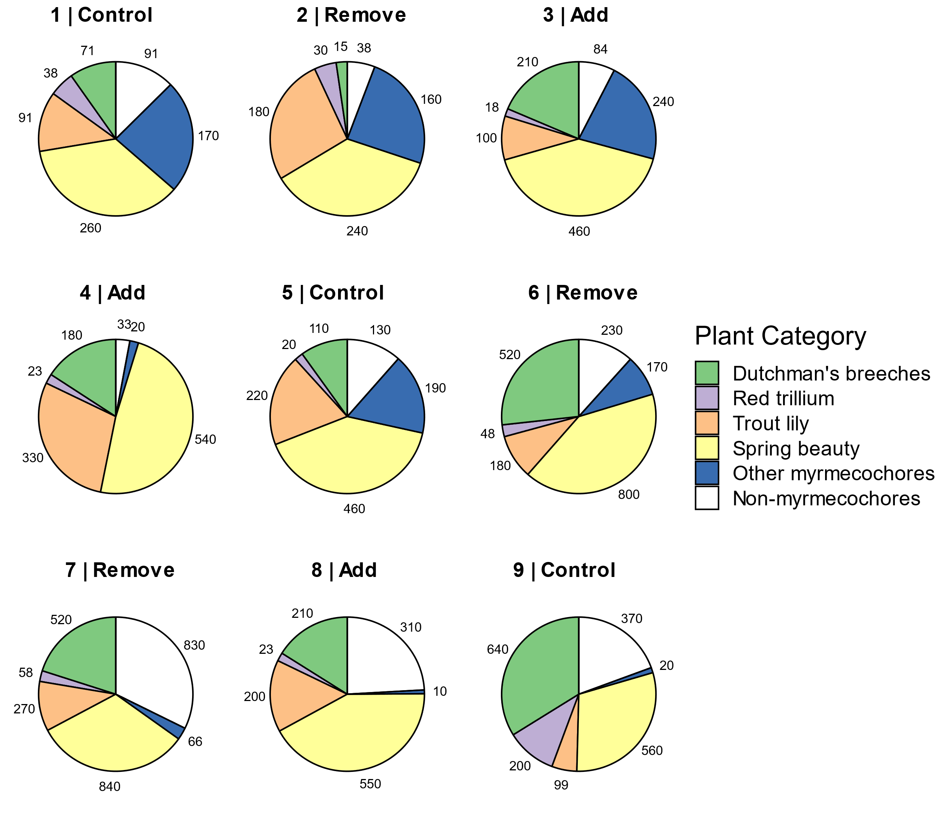

Fig 2.

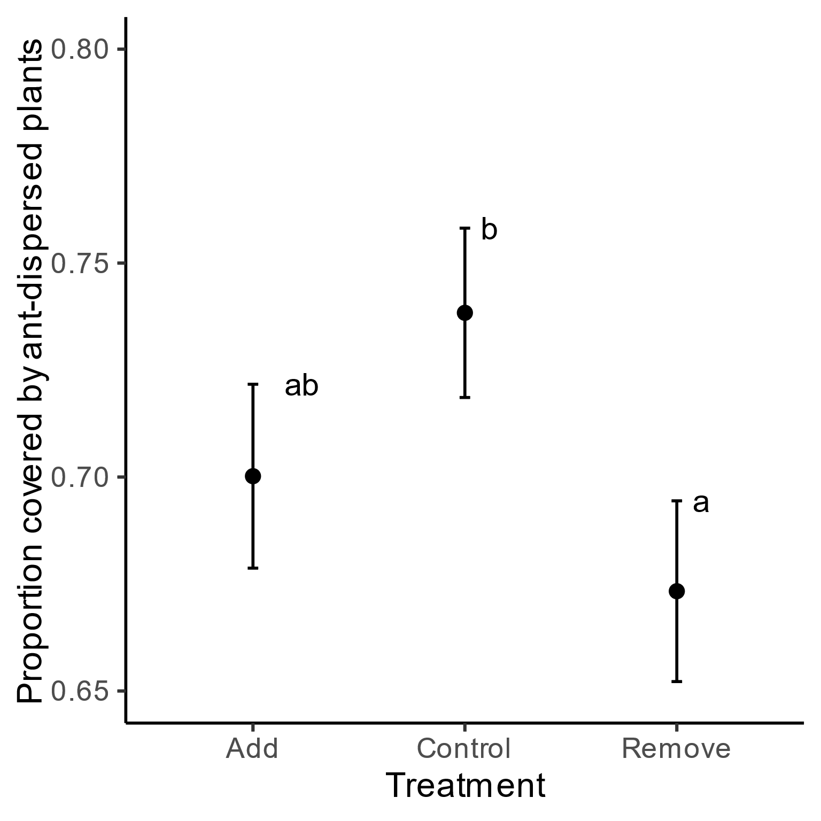

Fig. 3.

